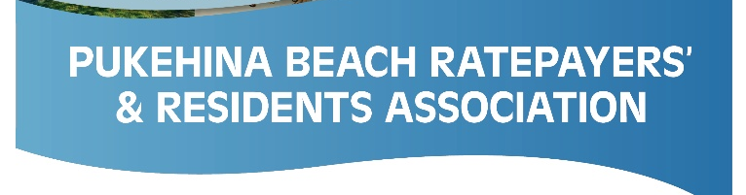

Kia ora koutou,

Pukehina Community Hall Update – September 2021

Although it may appear that not much is going on there is plenty happening in the background. Here’s an update to keep everyone in touch.

The WBOPDC has given us their utmost support now for retaining our Community Hall, and have assured us that they are there to help us through in every way. As you can imagine there are many meetings to be attended and plenty to discuss.

- In April this year the community was asked for their thoughts on a targeted rate to help fund the repairs the Hall needs in order to obtain a CPU (Certificate of Public Use). WBOPDC included this in the recent Long Tern Plan and a targeted rate for the Hall has now been adopted. This will appear on your rates bill in two installments: Insurance and maintenance; $6.50 and $30 for repairs. We are also aiming for outside funding to minimize the collection time of this rate.
- We are currently negotiating our Lease with WBOPDC for the land that the hall sits on, and the insurance for our asset. My feeling is that these should be settled over the next month.
- My Team and I are still awaiting a lot of pricing for the upgrade and repair work (fire system upgrade, external fire escape stairs and weather tightness repairs). Once we have these in, we can get on and move forward.

So, all in all, plenty to be done for our community hall and it is happening. We are doing our very best to get this done and will provide a further update as appropriate. If you would like to join the team to help out at any stage of the process, or have any questions, don’t hesitate to get in touch.

Here’s hoping everyone is safe and well.
Ngā mihi nui,
Kirsty – PRRA Hall Team Lead

